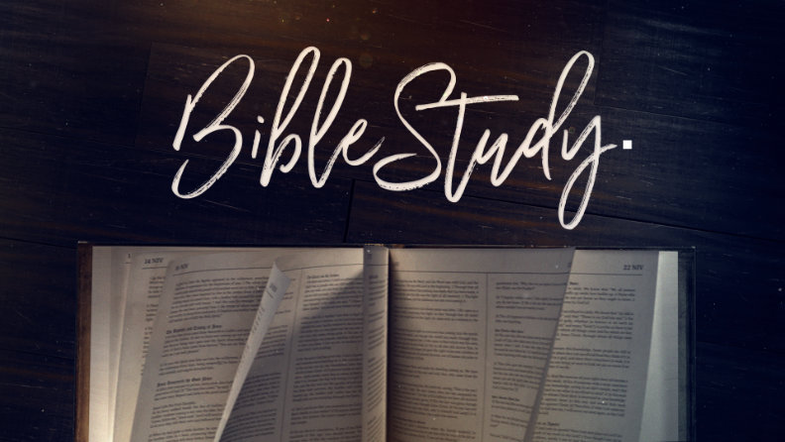

Bible Study "DIY" Series: Session 01
The Power of Storytelling

I. Series Topics Overview
- The Power of Storytelling — What can good storytelling do?
- Bible Study Prep — What tools do you need for great Bible study?
- Ancient Study Methods — How did ancient readers study the Bible?
- Contemporary Study Methods — What are the ways people study the Bible today?
- My Bible Study Walkthrough — Let's walk through the way I study

II. Enter the Story
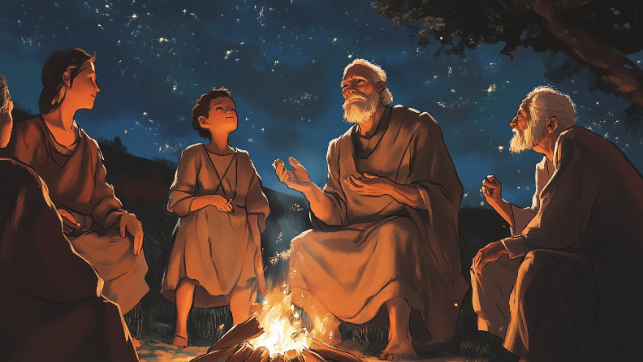
The Bible is an incredible treasure for those who study it. We have all benefited from God's word. But when thinking about going deeper in Bible study, we're confronted with the question Jesus gave to one of the teachers of the law:
Luke 10:25-26 (NIV): "On one occasion an expert in the law stood up to test Jesus. 'Teacher,' he asked, 'what must I do to inherit eternal life?' 'What is written in the Law?' he replied. 'How do you read it?'

Key Question: How Do You Read Your Bible?
- It is important how we read it
- Important when studying the Bible to help people become Christians
- Still important as we grow older as Christians
Dr. Guthrie's Definition: "Understanding the meaning of the text as much as we can given in the place, time and situation in which God revealed His truth."
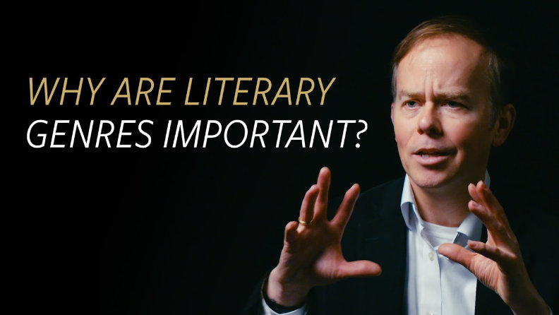
Video Resource: https://youtu.be/PiHJT7eK-9k

III. Modes of Communication
Different modes of communication serve different purposes:
- Movie (Narrative) — Tells a story through characters and plot
- News (Informative) — Presents facts and current events
- Opinion (Persuasive) — Argues a point of view
- Recipe (Instructional) — Provides step-by-step directions

"Check the Hot Sheets" — Men in Black
There is some truth in every genre — it just takes unpacking to better understand. For example, Star Wars contains truths about redemption and the power of friendship.

Real Dangers of Misunderstanding Genre

- Missing the rules of interpretation can mean life or death
- Mistaking an instructional sign for an opinion piece could get you killed
- This awareness is especially important when reading Scripture

IV. Literary Genre
Definition: Literary genre is the form used (by the author) and the rules governing its interpretation.
- Different types of storytelling have specific rules that apply
- Knowing the genre helps tune your mind to interpret information correctly
- We do this intuitively in everyday life

Types of Writing Styles
- Expository — Exposes/sets forth facts (textbooks, journalism, technical writing)
- Descriptive — Helps reader visualize in detail (fiction, poetry, advertising)
- Persuasive — Influences reader to assume author's point of view (ads, editorials, reviews)
- Narrative — Tells a story with characters (fiction, biographies, anecdotes)

Biblical Literary Genres
- Apocalyptic (like a Comic Book) — Exaggerated language, symbolic imagery
- Narrative (like a Novel) — Characters, meaning, symbolism, foreshadowing
- Poetic (like an Album) — Word pictures, very descriptive, artistic, purposeful structure
- Legal/Instructional (like the Constitution) — To the point, factual, orderly

V. The Power of Storytelling

The "Significant Objects" Experiment
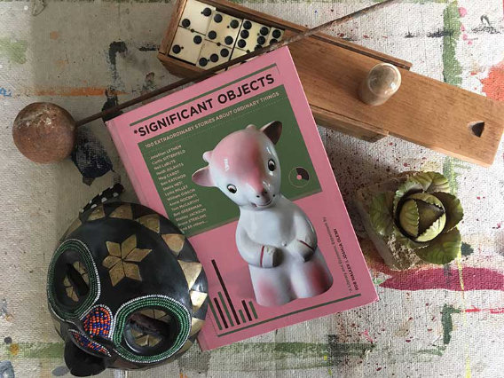
NY Times journalist Rob Walker and writer Joshua Glenn wanted to see if telling a story about an ordinary object could make people think it was worth more money.
- Objects purchased for $1.25 on average from thrift stores
- Over 200 writers contributed short stories for each item
- Items auctioned on eBay with the stories as descriptions

Original Price: $0.75 → Sold For: $81
Total Results: Bought for $121 → Sold for $8,000

How Your Brain Responds to Stories

Karen Eber: How your brain responds to stories — and why they're crucial for leaders

How God Uses Storytelling
- Storytelling makes up approximately 50% of the Old Testament
- Storytelling makes up approximately 60% of the New Testament


VI. Rules for Interpreting Biblical Narrative
- Interpret through plot and character development — Understand theological points by tracing story arcs, key turning points, and character growth or failure
- Look for implicit theology, not overt doctrine — Narratives often teach through example or consequence, not direct command
- Pay attention to setting and sequence — Time, place, and narrative flow are essential to meaning and application
- Look for symbolism, repetition, and double meaning — These are embedded intentionally within the text

Common Biblical Symbols
- Numbers: 1, 2, 3, 6, 7, 10, 12
- Animals: snake, dove, lamb, sheep, lion, donkey, bull, fox, vulture
- Nature: mountain, sea, valley, garden, rock, fire, water, vine, tree, seed
- Food: oil, bread, honey, meat, wine, fish, grapes, figs, fruit, salt

Key Concepts
Symbolism: Words with ambiguous meanings require careful analysis to determine if they should be interpreted literally or figuratively. Following word patterns across related passages helps reveal intended meaning.
Repetition: Look for recurring patterns in images, words, or themes. Striking phrases at pivotal story moments often highlight key developments or themes.
Double Meaning: Look for ambiguous or ironic phrases with multiple possible meanings. Pay attention to figurative language and how characters' roles shape interpretations.

VII. Practice: Ruth 1:1-5
Ruth 1:1-5 (NIV): "In the days when the judges ruled, there was a famine in the land. So a man from Bethlehem in Judah, together with his wife and two sons, went to live for a while in the country of Moab. The man's name was Elimelek, his wife's name was Naomi, and the names of his two sons were Mahlon and Kilion. They were Ephrathites from Bethlehem, Judah. And they went to Moab and lived there. Now Elimelek, Naomi's husband, died, and she was left with her two sons. They married Moabite women, one named Orpah and the other Ruth. After they had lived there about ten years, both Mahlon and Kilion also died, and Naomi was left without her two sons and her husband."

Clues from Setting and Context
- "In the days when judges ruled" — Judges 21:25: "In those days Israel had no king; everyone did as they saw fit."
- "A famine in the land" — Both literal famine and spiritual famine at the end of Judges
- "Bethlehem" ("house of bread") in "Judah" ("praise") — They left the land of Bread and Praise due to famine

Clues from Names
- Moab — "waste; nothingness" (Lot's son, born of incest in Genesis 19; Psalm 108:9 calls it "God's washbasin")
- Elimelek — "God is my king"
- Naomi — "Pleasant, beauty and grace"
- Mahlon — "Sickly, weak"
- Kilion — "Wasting away"
- Ephrathites — "Fruitful" (further emphasis of being far from blessing)
- Ruth — "Beauty; something worth seeing; friendship"
- Orpah — "Fawn"

Clues from Numbers and Repetition
- "Ten years" — Number ten symbolizes completeness (10 Commandments, 10 generations Adam to Noah, 10 plagues, etc.)
- "Turning back" — The phrase appears 10 times in chapter 1, possibly connecting to Lot's wife who "turned back"
- This is treasure hunting—you can see how far the rabbit hole goes!

VIII. Resources
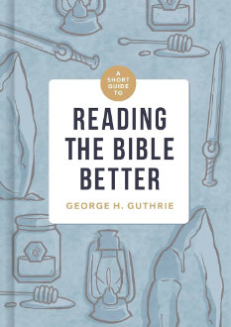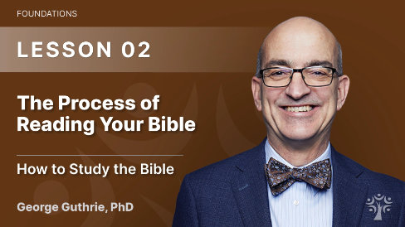

Study Material for This Lesson
- How to Study the Bible Series — biblicaltraining.org/learn/foundations/th102-how-to-study-the-bible
- Reading the Bible Better by George H. Guthrie
- Dictionary of Biblical Imagery
- Significant Objects Website: significantobjects.com
- Bible Cross-Reference Visualization: chrisharrison.net/index.php/Visualizations/BibleViz

